Gene Connect

Design Document
Version 1.1

[Insert approval date of document]

Revision History
Date | Version | Description
July 07, 2006 | 1.0 | Draft document
August 15, 2006 | 1.1 | Adopter and reviewer comments addressed
August 18, 2006 | 1.2 | Incorporated Michael McCormick comments

TABLE OF CONTENTS
1. Introduction 3
1.1 Document Overview 5
2. COmponents 6
2.1 Retrieve Annotations 6
2.1.1 Annotation server framework 6
2.1.2 Data Parsers 11
2.1.3 Sequence alignment (BLAST/Needle) 12
2.2 Schema Creation 15
2.3 PATH METADATA STORAGE 15
2.3.1 Configuration file for representing GeneConnect graph 15
2.3.2 Calculating Path Metadata 16
2.4 Post-Processing 17
2.5 Populating Summary tables 18
2.6 Query Interface 20
2.6.1 caCORE Like API 20
2.6.2 Web-Interface 23

Figure 1 – GeneConnect System Architecture 4
Figure 2 – Job Manager Class Diagram 7
Figure 3 - Activity Diagram for JobManager 8
Figure 4 – Class Diagram for ParserManager 10
Figure 5 – Sequence Diagram for ParserManager 11
Figure 6 - XML RPC Server Design 14
Figure 7 - GeneConnect graph 15
Figure 8 - Class diagram for all-to-all path calculation 17
Figure 9 - Data model for populating summary table 19
Figure 10 - Web interface block diagram 25

Introduction
The main goal of GeneConnect is to provide a mapping service which will interlink all approved genomic identifiers. To achieve this goal, the GeneConnect application has to perform the following high level tasks:
- An ETL(Extract, Transform, Load) tool to process the annotations
- Post processing to calculate all-to-all links
- Query Interface: Application and API
The ETL component downloads data from different data sources, processes and uploads the data into the database. This processing includes deriving pair-wise linkage between sources either using the information stored in the individual data sources (for example, Entrez gene contains UniGene identifier), or by sequence alignment for sequences in databases for which no annotation exists. The GeneConnect ETL component is designed on top of the caFunctionExpress (caFE) code base where in the caFE architecture is enhanced to be a generic annotation server where parsers for new data sources can be plugged into the annotation server without doing any code change. The parsers can be written in any language as long as they follow certain defined protocols (like command line parameters).

The post processing component is instantiated after the ETL tool has loaded all the data into the database. The post processing component calculates all possible traversal paths from one data source (also referred to as node) to all the other data sources and stores this information in a table. This procedure will be executed whenever a new data source is added to GeneConnect.

Once the data is loaded into the database, this data can be queried using one of the following methods: programmatically using the caCORE APIs, by making queries to the caGrid data service, or using the web based query interface. Users can query for one or more gene identifiers given one or more gene identifiers. Optionally users can also specify the order of node traversal between the start and end nodes in which case the query interface will return identifiers based on the order of node traversal.

The web-based user interfaces is based on the Java/Struts framework. The design follows the Model View Controller (MVC) design approach wherein the view (i.e. the user interfaces) and the model (i.e. the actual application logic) are completely insulated.

Figure 1 – GeneConnect System Architecture below shows the high-level block diagram for Gene Connect system architecture.
Unigene

Ensembl
GeneConnect System Architecture
Web Server
AnnotationParser Library
Gene Connect Server
Data Downloader Thread

Data file queue
Data Transformer Thread
Database Loader Thread

Parsed data file queue

Gene Connect Database

Correlate Genomic Identifiers

Push Downloaded file in queue
Transformed data file
Consume downloaded File
Download Data File using FTP, HTTP API
Write data to GeneConnect database

Spawn new thread
Spawn new thread
Spawn new thread
Consume parsed file
HTTP request
Objects

J O B M A N A G E R

API
caCORE API
caGRID API
Public Data Sources
Web browser
Java Apps
XMLRPC Server (for BLAST)

Figure 1 – GeneConnect System Architecture

Following describes the Gene Connect flow in annotation update mode and query processing:
Step 1 – Data download, transform (create pair wise link) and upload
- JobManager class is the master controller class of all the proceedings. It spawns multiple threads for downloading, parsing and data loading.
- The downloader threads download the data from different data sources and copies the data on the local machine.
- The transformer threads can be simple parsers for the data downloaded or can be components like BLAST for sequence alignment operations.
- The transformers process the downloaded files and obtain pair-wise mappings between data sources for each genomic identifier in each data source, by parsing the data files. For each data source a correlation table is created to store mapping information.
- The transformers can either directly load the output into the database or into text files which can then be loaded using the database loader threads.
- Transformers can be written in any programming language and can be plugged into the framework without any code change to the annotation server.
- High throughput sequence alignment is performed on clustering using an XML RPC server. The output of this sequence alignment is then stored in text files which is transferred back to the annotation server.
- Dataloader threads upload the data into text files using high throughput load mechanisms like Oracle SQLLoader.

Step 2 – Create all-to-all links and Order of Node Traversal (ONT)
- Once all the data is downloaded, processed and uploaded into the database, the next step is to calculate all possible traversal paths from one data source to all the other data sources and stores this information in a table.
- Using pair-wise links created by the transformers, the all-to-all link containing all possible combinations of genomic identifiers for all paths and the order of node traversal (ONT) is calculated.

Step 3 – Query interface (API and web application)
- Provides a caCORE like API and caGRID API which takes in any object in the GeneConnect UML model and returns any object in the model. The user can traverse the UML model using the associations within the model. These APIs run within a web server. User can call these APIs from a standalone application. These APIs are also internally used when the user makes a request through the browser.
- Users can specify the desired order of node traversal and the type of link for each pair of genomic identifiers (annotation, inferred annotation, exact match, inexact match).
- A web interface will be built using the caCORE APIs which will allow users to perform the all the important use cases.

Document Overview
This document captures design descriptions for the Gene Connect project. The design sections are organized as follows:
- SYSTEM ARCHITECTURE: Describes the high level architecture of the system as a whole.
- COMPONENTS: Describes the design of all the components of Gene Connect individually.
- PROCESS FLOW DIAGRAM: Describes the process flow
- UML REPRESENTATION: Includes Class diagram and Activity diagram.

COmponents

The following section describes different components in GeneConnect, along with their functionality. These include retrieve annotations, post-processing, calculation of frequency and confidence score, and query interface.

Retrieve Annotations
This section describes:
- ETL process that is used to download annotations from public databases
- Parse and store data into different base tables
- Optionally perform sequence alignment.

Annotation server framework
One of the main premises of this design is to reuse the caFE code base since both projects follow similar ETL architecture. caFE project was designed to achieve high degree of parallelism by making components modular and multi-threaded. However in the caFE design, the individual parsers were hard coded as part of the caFE executable. The disadvantages of this approach are:
- Addition of new parsers will mean code changes to the caFE code base.
- Only single downloaded file can process by transformer. This approach will not work in GeneConnect as the data transformer like sequence alignment (BLAST) requires more than one input / downloaded files to process.
- Parsers have to be written in Java. This is a considerable disadvantage considering that often tried and tested parsers are available for all data sources and which are not necessarily written in Java.
Considering this, in this release, we are enhancing the caFE server architecture to be an annotation framework wherein the actual data parsers are abstracted out.
- New parsers can be plugged in for new data source without any code changes to the main framework.
- The annotation framework will handle multiple files for transforming. The intermediate thread between data downloader and data transformer thread will work to monitor the required files is downloaded and available so that data transformer can proceed with further operation.
- The annotation framework will handle downloading files, spawning parser threads and database loader threads wherein this case, the parser threads will actually invoke an external parser.
Note: For more information on data downloader module, data parser module and database loader module of caFE annotation library please refer to caFE Design Document.

Following section describes enhancements made in design of caFE for using it as an Annotation parser library.

JobManager Class
The JobManager class provides the main() method to start the application. The Builder class contains the most of the business logic that controls other components like down loaders, parsers and so on.

GeneConnect reuses the multi-threaded downloader component, parser component and database loader component of caFE library. The business logic implemented in Builder class of caFE was specific to caFE application. The enhancement has been made in way to provide the extension mechanism which allows implementing the application specific logic along with using caFE’s core functionality of downloading and parsing. Class diagram outlines the enhanced structure:
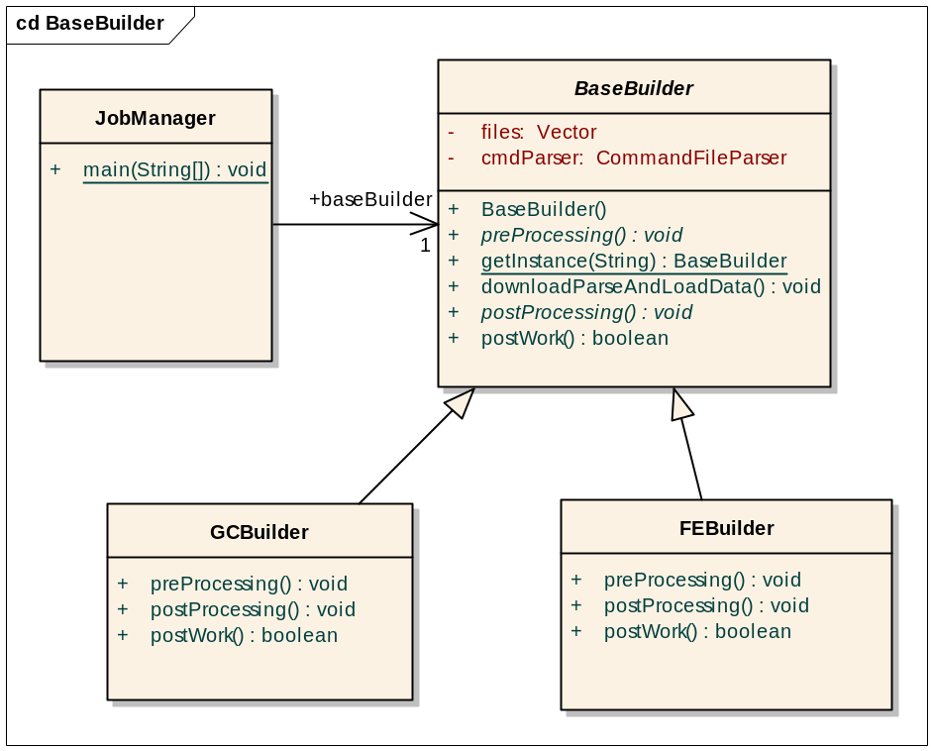
Figure 2 – Job Manager Class Diagram
The purpose of JobManager is to invoke the methods provided by BaseBuilder sequentially.
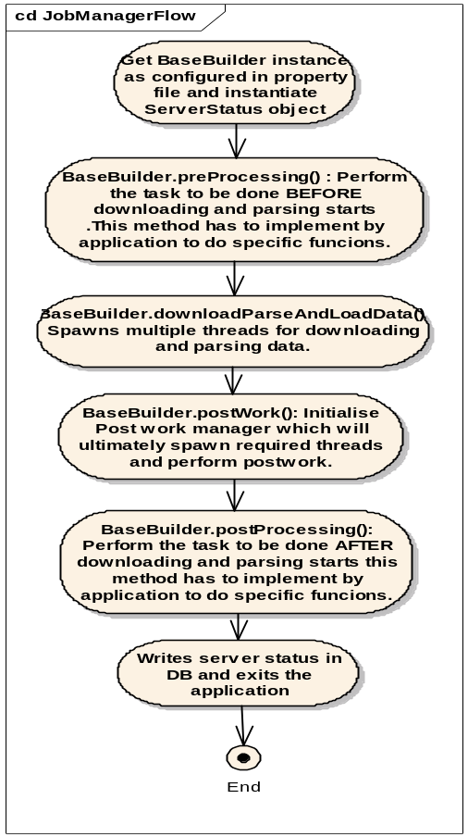

Figure 3 - Activity Diagram for JobManager

BaseBuilder Class
This Abstract Java class provides the default implementation for instantiating download manager, parser manager and data load manager, each of which will start multiple threads to carry out the respective functionality of downloading, parsing and loading data from data sources. This class also provides the abstract methods where the application using annotation parser library implements application specific logic.

Following are the implementation detail of methods and constructors provided by BaseBuilder.

BaseBuilder()
This default constructor loads application configuration property file, initializes information about files to download and processes taxonomy data.

public abstract void preProcessing()
This method gets called by JobManager before downloadAndParseData(). Any application specific functionality before downloading and parsing must be implemented in this method.

public void downloadAndParseData()
This method instantiates and starts the multi-threaded downloader, parser and database loader components. It also initializes the queue which is shared by these components. Normally applications may not be required to override this method.

public boolean postWork()
This method initializes the Post work manager which will ultimately spawn required threads and perform post work. Applications may choose to provide their own implementation.

public abstract void postProcessing()
This method gets called by JobManager after postWork() The application specific functionality that must be processed after downloading and parsing must be implemented in this method.

public abstract void caCoreProcessing()
This method gets called by JobManager after postProcessing(). The application specific caCore function (if any) that must be processed after downloading and parsing thread starts, must be implemented in this method.

GCBuilder Class (Extends BaseBuilder)
The GCBuilder class is the GeneConnect specific implementation of abstract BaseBuilder class. The sole purpose is to do application specific pre and post processing task before and after respectively downloading and parsing.

External Parser Invoker
The concept of external parser is as follows:
- Developers can choose to develop individual parsers and transformers in any programming language as long as they can be executed via command line.
- These parsers are external to the main annotations framework and can be plugged into the framework without having to do any code changes to the framework.
- The parsers will have to conform to certain guidelines dictated by annotation server framework. The parsers will have to accept a configuration file via command prompt using a –f option. The syntax of parser execution command must be ‘externalParserCommand –f <configuration_file>’.
- The annotation server framework uses this configuration file to pass information to the parser, like location of the files to the processed and location of the directory where it expects the output data to be placed.
The output of parsers can be one of the following:

- Directly load the output data into the database.

- Write the output into files. If parser writes the output into files, the dataloader threads in the annotation framework will load the data into the database.
NOTE: There could be multiple files generated per parser because one parser may update data into multiple tables. These files should be copied in a base directory specified in the input configuration file. The annotation server will then take all the files in that directory and upload them into the database.

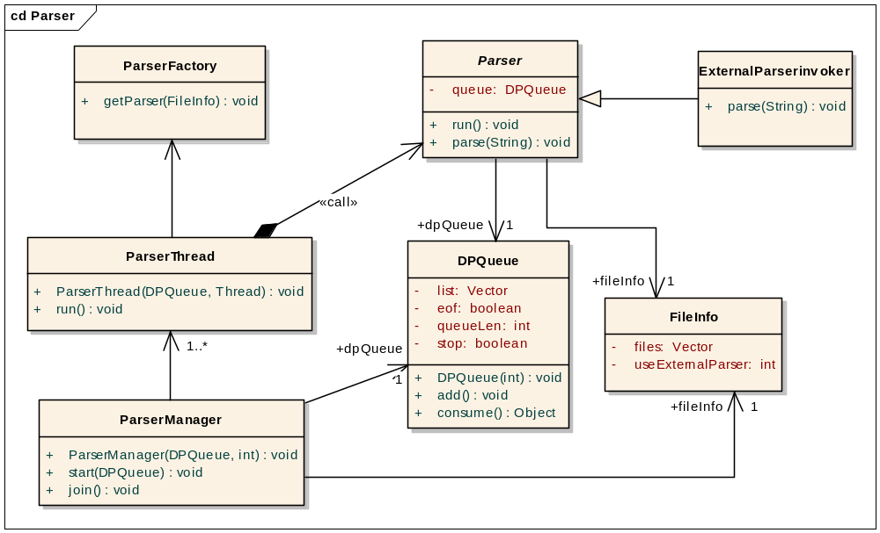
Figure 4 – Class Diagram for ParserManager

The job of ExternalParserInvoker class is to:
- Prepare the configuration file and execute the command
- If parser writes into a file, then that file will be pushed in the data downloader queue by ExternalParserInvoker so that data loader threads can load it into the database.

Following activity and sequence diagram depicts the process flow of ParserManager with respect to external parser.

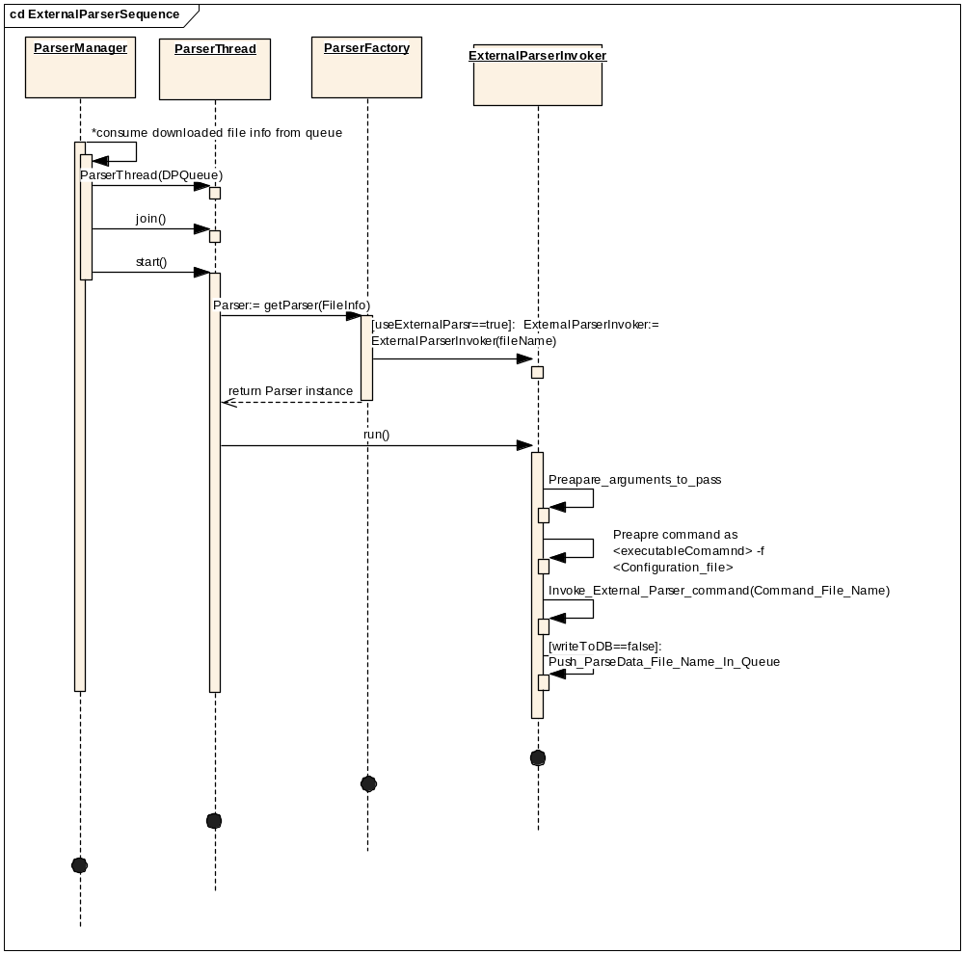
Figure 5 – Sequence Diagram for ParserManager

Data Parsers

The following is the list of parsers implemented for Gene Connect:

Data Source | Language | Description
Entrez gene | Java | caFE server already gets the Entrez gene data. The same will be reused here.  Separate Perl parser written to get RefSeq links.
UniGene | Java | External parser code in Java will be written to fetch UniGene data.
GenBank mRNA | Perl | The BLAST for GenBank mRNA against Ensembl Transcript and RefSeq mRNA will be performed on the cluster.
GenBank Protein | Perl | The BLAST for GenBank Protein against Ensembl Protein and RefSeq Protein database will be performed on the cluster.
RefSeq mRNA and protein | Perl | Handled by Entrez parser.
Ensembl Gene, Transcript, Protein | Perl | BioPerl modules are used to parse the Ensembl data files.
UniProtKB |  | Perl parser written for this.
Table 1 : GeneConnect parsers

Sequence alignment (BLAST/Needle)
For each sequence in one database that requires mapping to a second database, but for which no direct annotation exists from the given data source, sequence alignment needs to be done.

BLAST/Needle is treated as another kind of transformer which follows the same control flow as any other external parser i.e. data downloader downloads the files, BLAST/Needle is performed on it and stores the output in a text file, and the data loader uploads the data into the database.

This sequential process will include:
- Downloading the source FASTA files that contain the input sequences for sequence alignment.
- Downloading the destination FASTA files.
- Running the FASTA files through ‘formatdb’ to generate the database which will be used by sequence alignment.
- Performing sequence alignment operation for each sequence in the source data file. Performing Needle and other post-filtering steps, as described below.
- Updating the base tables for the current data source with pair-wise mappings between input sequence identifier and destination sequence identifier.
Following are steps for sequence alignment (BLAST/Needle/post-Needle filtering): Note that these parameters are configurable.
- The sequence from the source database is used as the query sequence for BLASTN or BLASTP (as appropriate), whose parameters are shown in tables below.
- Any sequence in the BLAST results that has an expect value less than 1x10⁻⁵ is retained for further analysis.
- For each retained sequence, the maximum possible alignment length is calculated, given the relative position of the sequences in the alignment relative to each other. It includes the length of the sequence on the 5’-most end that could have aligned but did not due to mismatches, and length of the sequence on the 3’-most end that could have aligned but did not did not due to mismatches.
- Any sequence alignment that meets or exceeds 80% of the maximum possible alignment length is retained for further analysis.
- If more than one sequence passes through the BLAST filter, each will be aligned to the query sequence using the “needle” global alignment algorithm from the EMBOSS software package, whose parameters are shown in Table 2: BLAST parameters. Any sequence alignment that meets or exceeds 90% of the length of target sequence and has a similarity percentage of at least 90% to the target sequence is retained for further analysis.
- The sequence(s) with the top score and sequences that do not have the top score but contain at most two mismatches per 1000 base pairs will be selected and stored as the most appropriate(s) match for the query sequence.

Parameter | BLASTN Value | BLASTP Value
E value | e^-25 | e^-12
Scoring Matrix | N/A | BLOSUM-62
Gap open cost | 5 | 11
Gap extension cost | 2 | 1
Dropoff (Z) | 50 | 25
Word size | 11 | 3
Table 2: BLAST parameters

Parameter | Nucleotide Alignment Needle Parameters | Protein Alignment Needle Parameters
Gap open | 10 | 10
Gap extend | 0.5 | 0.5
Matrix | EDNAFULL | EBLOSUM62
Table 3: Needle parameters

Clustering Operation
Sequence alignment is a time intensive process. This overhead can be partially mitigated by dividing the sequence alignment task amongst a number of cluster nodes, each of which will be managed by a central server. The sequence of tasks is as follows:
Set up a ‘Master’ XMLRPC server. This server in turn controls number of cluster nodes, each of which has its own CPU.
Pass input for sequence alignment to the master server through XMLRPC client call.
The master server delegates the sequence alignment task to the clusters. For each sequence alignment that has to be done, the master server sends this job to the next available free cluster. The master server also stores the results from all the clusters.
The master server returns the results of sequence alignment to the calling program.

Figure below shows the block diagram of the XMLRPC set up:

XMLRPC Client
Cluster 1
Cluster 2
Cluster 3

Master XMLRPC Server
Job Queue
Machine Queue
Input
Results

Figure 6 - XML RPC Server Design

Schema Creation
The GeneConnect database schema stores genomic identifier information and their mappings with respective data sources. Schema creation module will be called from the installer script for GeneConnect.
The following is a link to Enterprise Architect file containing the data model which captures the database schema and relationships of individual tables:
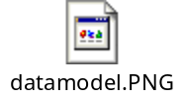

PATH METADATA STORAGE

Configuration file for representing GeneConnect graph
The GeneConnect graph is shown below:
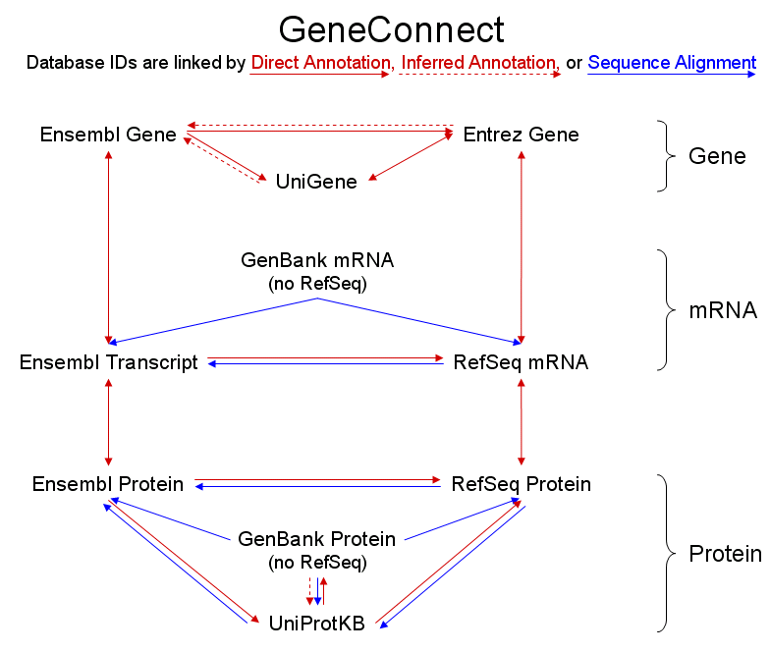
Figure 7 - GeneConnect graph
The above GeneConnect graph is stored in a user-configurable text file. The configuration (i.e.) data sources and the linkages between them, is explained with the help of a snap-shot of the file below, containing five data sources for illustration.
EnsemblGene, EntrezGene, UniGene, Ensembl Transcript, RefSeq mRNA
-1, 1, 1, 1, 0
1, -1, 1, 0, 1
1, 1, -1, 0, 0
1, 0, 0, -1, 1
0, 1, 0, 1, -1
Table 4 - Snapshot of text file representing GeneConnect graph
The first line of the file contains the data source names, separated by a ‘comma’ delimiter. The following lines contain information about the connections from each data source (in order, taken from the first line) to all other data sources. For instance, the line “1, -1, 1, 0, 1” (corresponding to Entrez Gene above) can be inferred as follows:
- Entrez Gene has a directional link (either direct or inferred or sequence alignment) to Ensembl Gene, UniGene and RefSeq mRNA (denoted by 1s in the first, third and fifth position);
- Entrez Gene does NOT have a directional link to Ensembl Transcript (denoted by 0 in the fourth position)
- The second position has the value -1, which denotes Entrez Gene to itself link.

Calculating Path Metadata
As mentioned above in section 2.3, this involves calculating all possible paths from a given data source to all other data sources. The steps are as follows:

- The text file containing the comma-separated values is read into memory into a 2-Dimensional array as shown in the table below.

 | EnsemblGene | EntrezGene | UniGene | Ensembl Transcript | RefSeq mRNA
EnsemblGene | -1 | 1 | 1 | 1 | 0
EntrezGene | 1 | -1 | 1 | 0 | 1
UniGene | 1 | 1 | -1 | 0 | 0
Ensembl Transcript | 1 | 0 | 0 | -1 | 1
RefSeq mRNA | 0 | 1 | 0 | 1 | -1
Table 5 - Array representing GeneConnect graph

- Consider the row for EntrezGene. The ‘1’s indicate that it is directly connected to Ensembl Gene, UniGene and RefSeq mRNA. This direct connection forms one path from EntrezGene to each of the three data sources.
- In the same row for EntrezGene, consider the link to Ensembl Transcript. The value is 0, which implies that no direct link exists. At this stage, recursively calculate all paths from EntrezGene to the data sources that are linked to Ensembl Transcript. For instance, Ensembl gene is connected to Ensembl Transcript and Entrez Gene is connected to Ensembl gene. Use this information to construct the path: Entrez gene → Ensembl Gene → Ensembl Transcript. Thus a path from Entrez Gene to Ensembl Transcript is obtained, which can be used as an intermediate path while calculating paths from other data sources to Ensembl Transcript.
- Repeat steps 2 and 3 for every row (i.e.) every data source. At the end of these iterations, all possible orders of node traversals from any given data source to all other data sources is obtained.

The GeneConnectPathCalculator class is instantiated and methods will be executed at the time of creation of the database schema or whenever the configuration file changes.

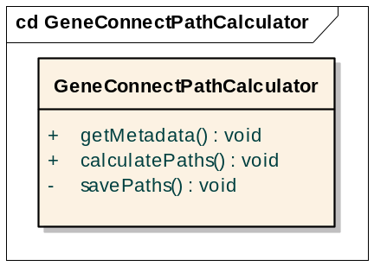
Figure 8 - Class diagram for all-to-all path calculation

Following are the implementation details of important methods provided by GeneConnectPathCalculator:

getMetadata(): This method reads into memory the GeneConnect graph stored in a file or database.

calculatePaths(): This method calculates every possible path from each node to all the other nodes.

savePaths(): This method saves the calculated paths into the database.

Post-Processing
Once the annotation data is loaded into the database along with the pair-wise links, the next step is to calculate the all-to-all paths between all the data sources. The following steps are involved:
- Read the GeneConnect data sources graph from a configuration file.
- For each data source, calculate all possible paths to every other data source and store it in the database. This constitutes the ‘path metadata’.
- Using the above metadata and pair-wise links stored in the base tables, create the linked set of genomic identifiers (which contains all possible combinations of genomic identifiers for all paths through the GeneConnect data sources graph), and the order of node traversal (ONT). This is stored in the ‘summary tables’.

Populating Summary tables
Pair-wise links between data sources are obtained for each genomic identifier in each data source, by parsing the data files and populating base tables. Path metadata is calculated, as described in the previous section. The pair-wise links and path metadata information are used to create the linked set of genomic identifiers (which contains all possible combinations of genomic identifiers for all paths through the GeneConnect data sources graph), and the order of node traversal (ONT). This constitutes the summary tables.
In order to illustrate how a linked set of genomic identifiers are generated, consider a pair of data sources Ensembl Gene and Entrez Gene:
The postProcessing() method of GCBuilder class performs the creation of summary tables. The execution steps for summary table creation are as follows:

- Consider any data source (say) Ensembl Gene.
- Repeat step 3 and 4 for each data source which is directly connected to Ensembl Gene.
- Updating of summary table for each link involves merging of two link tables that is created by parser either through direct annotation or sequence alignment.
- In this case link tables ‘EnsemblGene_EntrezGene’ and ‘EntrezGene_EnsemblGene’ are merged together. Merging also involves removing of duplicate records.
- Repeat above steps 1-4 for every data source.

In the table GENOMIC_IDENTIFIER_SUMMARY, the field GIS_SOLUTIONID in the table contains a unique ID denoting links between any two genomic identifiers that make up the entire path and a combination of such GIS_SOLUTIONID’s correspond to a path ID in the PATH_METADATA_SUMMARY table. For instance if a path consists of EnsemblGeneID1→ EntrezGeneID1 → RefSeqmRNAID1, there will be 2 entries in the summary table: one entry for the EnsemblGeneID1→ EntrezGeneID1 link and the other entry for the EntrezGeneID1 → RefSeqmRNAID1 link such that both the above links contain unique solution IDs but map to the same path ID.
The data model for summary tables, along with a single pair of base correlation tables (Entrez Gene and Ensembl Gene) is shown below:
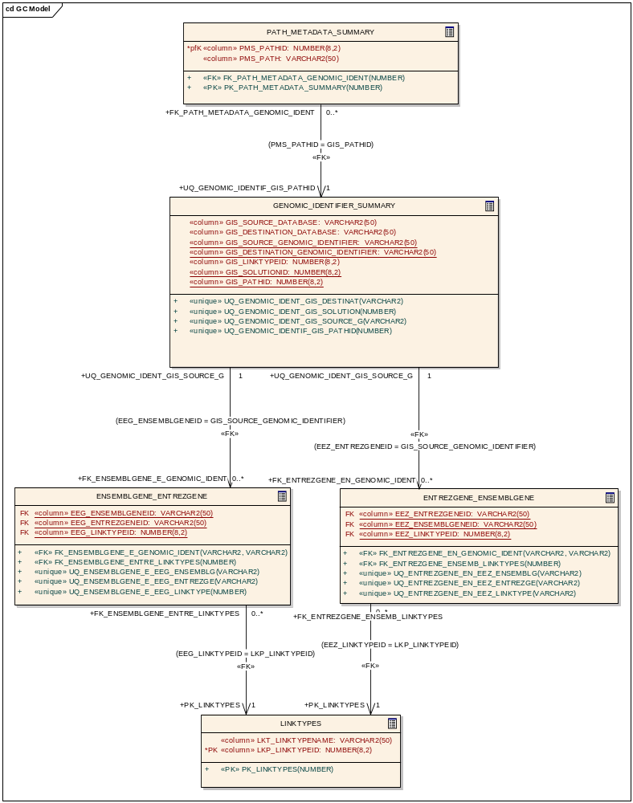
Figure 9 - Data model for populating summary table

Query Interface

caCORE Like API

Gene Connect provides caCORE Java APIs to enable programmers to query the system for order of node traversal from one to other genomic identifier and obtaining frequency of genomic identifier for given order of node traversal.
The caCORE architecture includes a service layer that provides a single, common access paradigm to clients using any of the provided interfaces. The methodology used for obtaining data from caCORE systems is that the domain objects is the input to the query methods that provide the criteria for the returned data. With this approach the objects which are associated with each other will be returned.

The user will populate the GeneConnect application domain object and call the application’s caCORE like API’s ApplicationService.search() method, also specifying the return type object. caCORE APIs will be modified/extended to implement the business logic specific to GeneConnect. The business logic includes obtaining pre-calculated paths from meta-data table, Calculating and search for genomic identifiers along the path in summary table, and calculating the confidence and frequency values (explained below). Both confidence and frequency will be calculated dynamically on the result set of genomic identifiers obtained and will not be stored in the database tables. A list of result objects is returned to the user. There will be a change only in the implementation and not in the interface or method signature provided by the caCore-like API, in other words, the user will query the system using the default caCore-like API.
The following section defines and explains the calculation of confidence and frequency.

Calculation of Confidence score and Frequency
Confidence score is defined as the ratio of number of occurrences of a unique ‘combination of genomic identifiers’ in a query, to the total number of traversable paths for the given input. Confidence score is calculated for a set of genomic identifiers and a given ONT
Frequency is defined as the ratio of number of occurrences of a ‘single genomic identifier’ in each combination of genomic identifiers to the total number of traversable paths for the given input.
The steps for calculating both Confidence score and Frequency are given below:
- For a given input genomic identifier belonging to a data source, the input source genomic identifier is considered as the center and every search result (consisting of genomic identifiers) is a distinct traversable path in the GeneConnect graph.
- Each such traversable path generates a row in the summary table and every time that particular set of genomic IDs is observed (via different orders of node traversals), the counter for that row is incremented by one. Similarly, each time a genomic identifier is observed, the counter for that identifier is incremented by one.
- The confidence score for a set of genomic identifiers in a row is the ratio of number of occurrences of that row to the total number of traversable paths for the given input. The frequency for a single genomic identifier is the ratio of number of the counter for that genomic identifier to the total number of traversable paths for the given input.
Some examples of how confidence score and frequency are calculated are listed below. For all of the examples shown:
- Ensembl Gene, Entrez Gene and UniGene are the 3 data sources considered here for illustration.
- Genomic identifiers in each data source are represented as A1, A2, B1, C1 etc.
- Order of node traversal is denoted as ONT.

Data Set 1:

Ensembl Gene | Entrez Gene
A1 | B1
A2 | B2
A2 | B3

Entrez Gene | UniGene
B1 | C1
B2 | C2
B3 | C3

Ensembl Gene | UniGene
A1 | C1
A2 | C2
A2 | C3

- Searching with A1 using ONT of Ensembl Gene-Entrez Gene-UniGene

ID from Ensembl Gene | ID from Entrez Gene | ID from UniGene | Confidence score | Frequency
 |  |  |  | A1 | B1 | C1
A1 | B1 | C1 | 1/1 = 1 | 1/1 = 1 | 1/1 = 1 | 1/1 = 1

- Searching with A2 using ONT of Ensembl Gene-Entrez Gene-UniGene

ID from Ensembl Gene | ID from Entrez Gene | ID from UniGene | Confidence score | Frequency
 |  |  |  | A2 | B2 | B3 | C2 | C3
A2 | B2 | C2 | ½ = 0.5 | 1/1= 1 | ½ = 0.5 | ½ = 0.5 | ½ = 0.5 | ½ = 0.5
A2 | B3 | C3 | ½ = 0.5

- Two ONT’s are possible when starting at Ensembl Gene: Ensembl Gene-Entrez Gene-UniGene and Ensembl Gene-UniGene-Entrez Gene

  - Searching with A2 using ONT of Ensembl Gene-Entrez Gene-UniGene
ID from Ensembl Gene | ID from Entrez Gene | ID from UniGene
A2 | B2 | C2
A2 | B3 | C3

  - Searching with A2 using ONT of Ensembl Gene-UniGene-Entrez Gene
ID from Ensembl Gene | ID from Entrez Gene | ID from UniGene
A2 | B2 | C2
A2 | B3 | C3

Combining the above search results:
ID from Ensembl Gene | ID from Entrez Gene | ID from UniGene | Number of occurrences | Confidence Score | Frequency
 |  |  |  |  | A2 | B2 | B3 | C2 | C3
A2 | B2 | C2 | 2 | 2/4 = 0.5 | 4/4= 1 | 2/4 = 0.5 | 2/4 = 0.5 | 2/4 = 0.5 | 2/4 = 0.5
A2 | B3 | C3 | 2 | 2/4 = 0.5

Data Set 2:

Ensembl Gene | Entrez Gene
A1 | B1
A2 | B2
A2 | B3
A3 | B2

Entrez Gene | UniGene
B1 | C1
B2 | C2
B2 | C4
B3 | C3

Ensembl Gene | UniGene
A1 | C1
A2 | C2
A2 | C3
A3 | C4

- Two ONT’s are possible when starting at Entrez Gene: Entrez Gene-Ensembl Gene-UniGene and Entrez Gene-UniGene-Ensembl Gene
Searching with B2 using ONT of Entrez Gene-Ensembl Gene-UniGene:

ID from Ensembl Gene | ID from Entrez Gene | ID from UniGene
A2 | B2 | C2
A2 | B2 | C3
A3 | B2 | C4

Searching with B2 using ONT of Entrez Gene-UniGene-Ensembl Gene:
ID from Ensembl Gene | ID from Entrez Gene | ID from UniGene
A2 | B2 | C2
A3 | B2 | C4

Combining the search results:
ID from Ensembl Gene | ID from Entrez Gene | ID from UniGene | Number of Occurrences | Confidence score | Frequency
 |  |  |  |  | A2 | B2 | C2 | C3 | C4
A2 | B2 | C2 | 2 | 2/5 | 3/5 = 0.6 | 5/5 = 1 | 2/5 = 0.4 | 1/5 = 0.2 | 2/5 = 0.4
A2 | B2 | C3 | 1 | 1/5 = 0.2
A3 | B2 | C4 | 2 | 2/5 = 0.4

- Two ONT’s are possible when starting at node Ensembl Gene: Ensembl Gene-Entrez Gene-UniGene and Ensembl Gene-UniGene-Entrez Gene
Searching with A2 using ONT of Ensembl Gene-Entrez Gene-UniGene

ID from Ensembl Gene | ID from Entrez Gene | ID from UniGene
A2 | B2 | C2
A2 | B2 | C4
A2 | B3 | C3

Searching with A2 using ONT of Ensembl Gene - UniGene - Entrez Gene
ID from Ensembl Gene | ID from Entrez Gene | ID from UniGene
A2 | B2 | C2
A2 | B3 | C3

Combining the search results:
ID from Ensembl Gene | ID from Entrez Gene | ID from UniGene | Number of Occurrences | Confidence score | Frequency
 |  |  |  |  | A2 | B2 | B3 | C2 | C3 | C4
A2 | B2 | C2 | 2 | 2/5 = 0.4 | 5/5 = 1 | 3/5 = 0.6 | 2/5 = 0.4 | 2/5 = 0.4 | 2/5 = 0.4 | 1/5 = 0.2
A2 | B2 | C4 | 1 | 1/5 = 0.2
A2 | B3 | C3 | 2 | 2/5 = 0.4

caGrid Data Service

GeneConnect will be deployed as a caBIG compliant data service on caGrid 1.0. The GeneConnect data service will be created using the service deployment toolkit (Introduce) that will be available in the caGrid 1.0 release.

Web-Interface

GeneConnect’s web based queries internally uses the caCORE-like API’s to execute users’ query and return results.
The GeneConnect application is comprised of an n-tiered architecture, as depicted in the following figure. The client layer contains applications on the client side that request to perform operations on the server side. The web browser and Java HTTP API are two of the client programs in GeneConnect. The presentation layer provides a web interface as well as support for the HTTP API. The object layer is the heart of the application, and contains domain objects, model classes and the data access layer. This is the place where all genomic identifier related business requirements are fulfilled. The backend of the application is a local database which stores genomic identifiers and their mapping with other genomic identifiers.

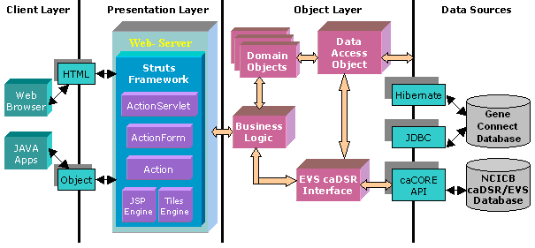
Figure 10 - Web interface block diagram
The main components of the application are as follows:
- Web interface: Web pages and HTTP APIs
- Business Logic
- Data access object
- EVS/caDSR interface
The web-based user interfaces are designed and developed in a Java/Struts framework. The design follows the Model View Controller (MVC) design approach wherein the view (i.e. the user interfaces) and the model (i.e. the actual application logic) are completely insulated.
The web interfaces communicate with external data sources like caDSR, EVS and GeneConnect’s database through an intermediate interface. The intention of the interfaces is to insulate the core application logic from any changes in the external data source.
Interaction with the database is performed using either Hibernate or JDBC based on performance requirements. Hibernate is used in cases where simple objects are to be inserted/updated in the database. In cases like query interface where high throughput queries can be expected, JDBC is used.

